ANSWER KEY – UNIT TEST – 22.05.2022
1 |  | any 2  1  1
2 |  | 1  1
3  4 | - insectide; antiseptic  - 1-Bromopentane; 1-Bromo-2-methylbutane  OR  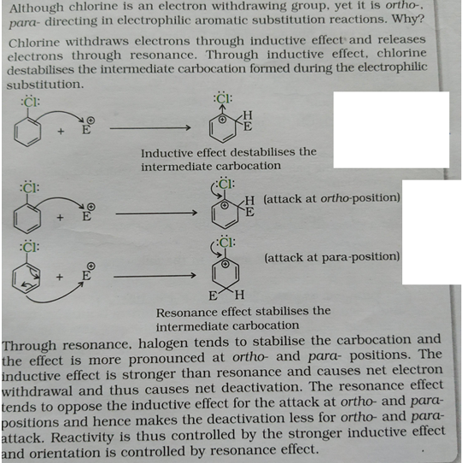  - Phenol – neutral Ferric chloride – violet colouration  Benzoic acid – does not answer  - But-2-en-1-ol  OR  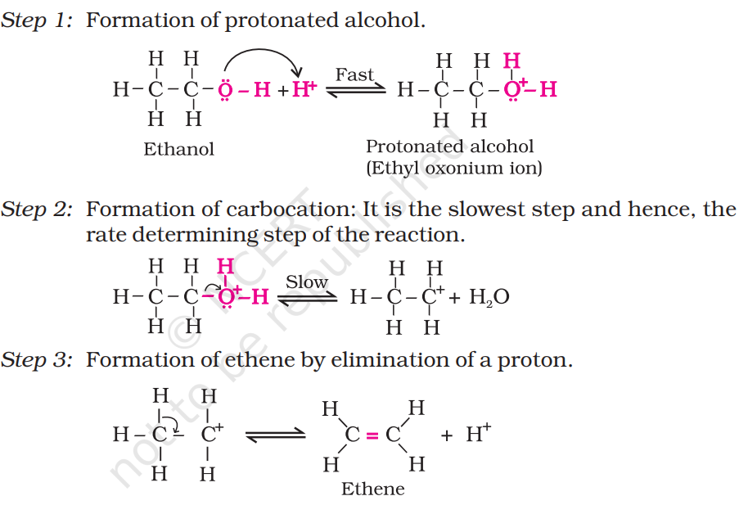 | ½ + ½  1+1  (reasons)  1  1  1  ½  ½  1  1  1  1  1
5 |  | 6x1/2 =3
6 | - due to the repulsive interaction between the two bulky (–R) groups.  - acetone as a byproduct which is also a commercial product  - Intermolecular H-bonding Vs van der Waals forces | 1  1  1
7 | - Chloroethane b. 4-Ethylphenol c. 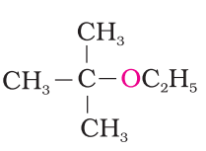 | 1 +1=+1
8  9. | - The objects which are non-superimposable on their mirror image (like a pair of hands) are said to be chiral and this property is known as chirality + Example  - Groups like cyanides and nitrites possess two nucleophilic centres and are called ambident nucleophiles + example  - A mixture containing two enantiomers in equal proportions will have zero optical rotation, racemic mixture or racemic modification+example  - (A) < (B) <(C) – Alcohols with halogen acids  - (a) < (c) < (d) < (b) - densities  - (c) < (a) < (b) – boiling point  OR  - (a) < (c) < (b) – reactivity towards nucleophilic substitution.  - B<A<C – melting point  - C6H5C(CH3 )(C6H5 )Br > C6H5CH(C6H5 )Br > C6H5CH(CH3 )Br > C6H5CH2Br (SN1) | ½ + ½  ½ + ½  ½ + ½  1+1+1  1+1+1
10.A  10B | OR  Resonance of Anisole + Explanation | 1+1+1  1  1  OR  1+1

